**Exploratory testing results:**

1. **Bug ID:** 1
2. **Title:** Page Not found
3. **Environment:** (Device = iPhone 14 Pro Max, Pixel 7

OS,

Browser = chrome mobile view ,

App version,

1. **Steps to Reproduce:** 1. Go to main page
   1. Right click in mouse button anywhere and click on inspect
   2. Set iPhone 14 pro max as a dimension
   3. Click on contact us button
   4. This issue is not stable sometimes working properly
2. **Expected Result:** contact us page should display
3. **Actual Result:** it displays some js code
4. **Severity:** Medium (From Customer point of view. There is no other option to contact us)
5. **Additional Notes:** Nil
6. **Screenshots/Videos:**

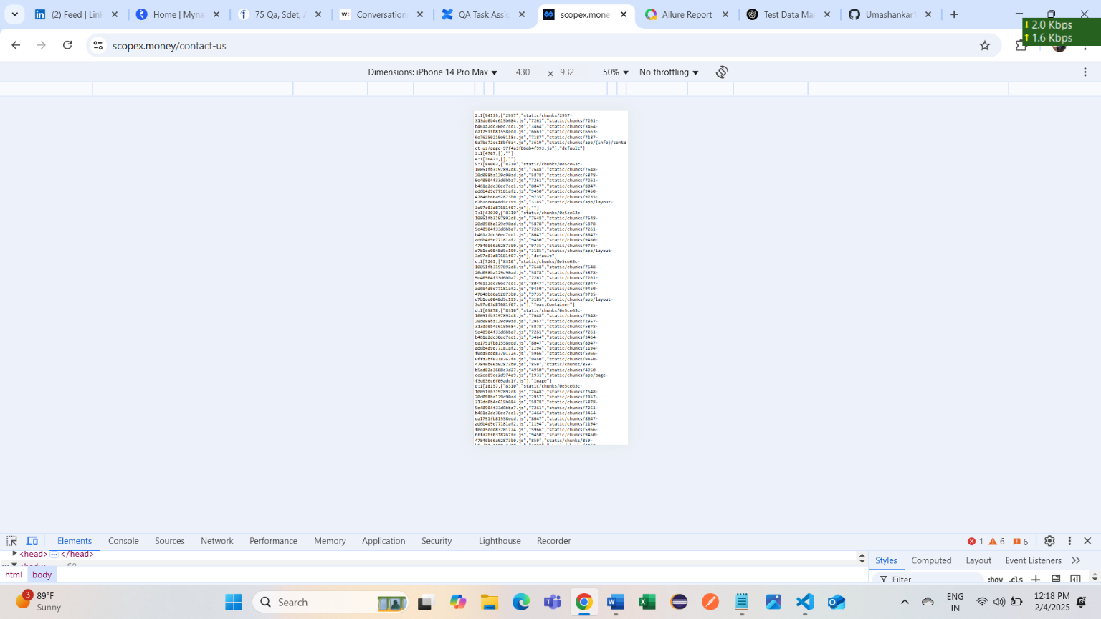

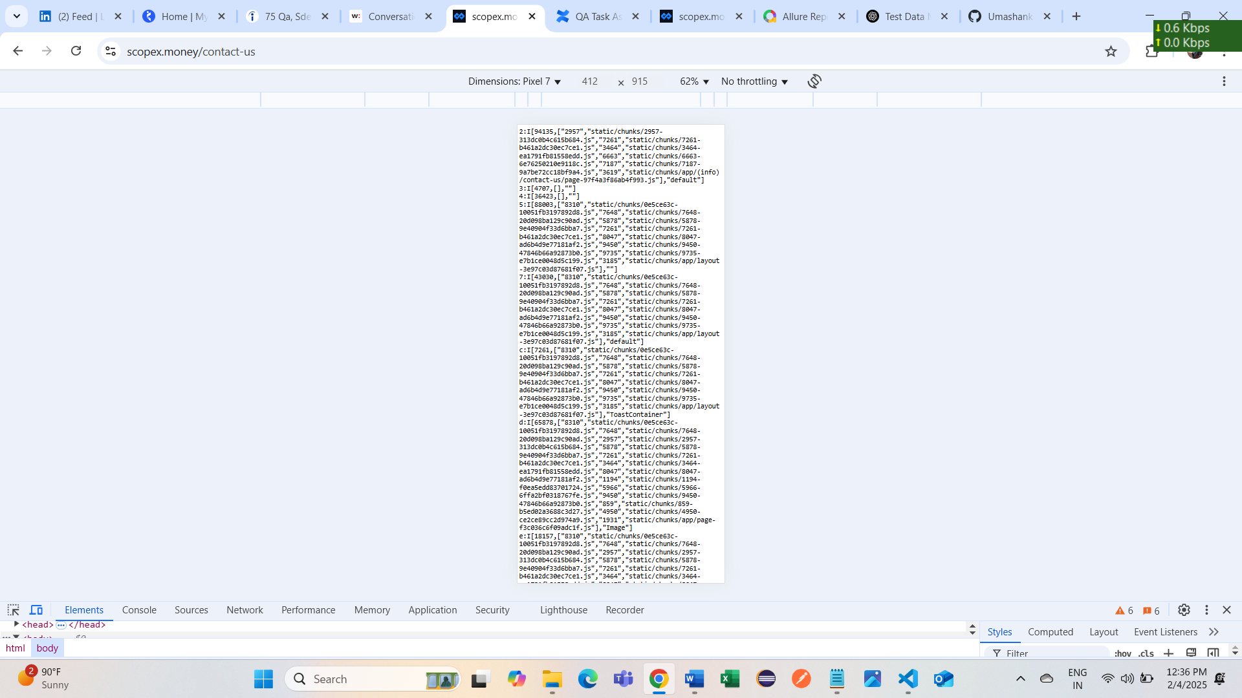

1. **Bug ID: 2**
2. **Title:** Help Chat Box not working
3. **Environment:** (Device = iPad Air , ipad Pro , Asus Zenbook fold
4. OS,
5. Browser = chrome mobile view,
6. App version,
7. **Steps to Reproduce:** Go to main page

Right click in mouse button anywhere and click on inspect

Set iPad Air as a dimension

Click on help chat box available right-side corner

1. **Expected Result:** Chat box will open and able to chat
2. **Actual Result:** Chat box not opening
3. **Severity:** Low
4. **Additional Notes:** Nil
5. **Screenshots/Videos:**

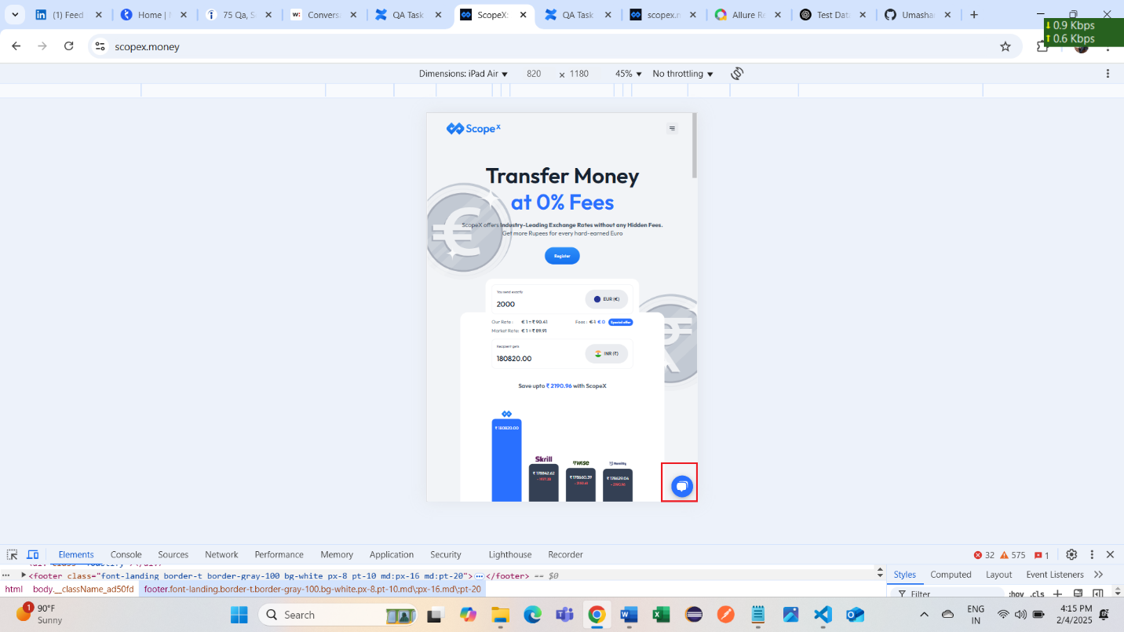

Date: 2/5/2025

Bug 3: Same “contact us” page not found in web view

